# CUSTOMER CARE REGISTRY



TECHNOLOGY ARCHITECTURE

# TEAM MEMBERS

TEAM LEADER : Vigneshwaran D

TEAM MEMBER 1 : Suresh kumar R

TEAM MEMBER 2 : Suriyan D

TEAM MEMBER 3 : Azil Krishnan S

# TEAM DETAILS

Team No : PNT2022TMID31494

College Name: Dr.N.G.P.Institute of Technology

Department: Electronics and Communication & Engineering

## TECHNOLOGY ARCHITECTURE

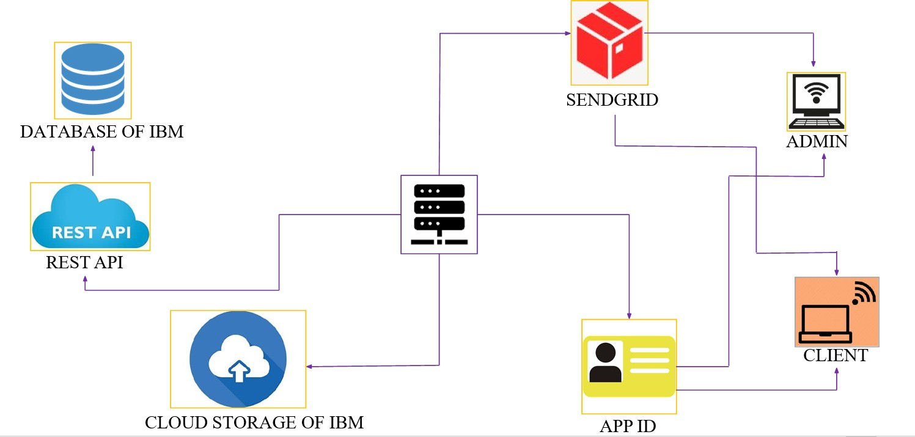

**TECHNOLOGY ARCHITECTURE**

|  |  |  |  |
| --- | --- | --- | --- |
| **S.NO** | **COMPONENT** | **DESCRIPTION** | **TECHNOLOGY** |
| 1 | User Interface | Through chat bots, mobile apps, or web user interfaces the user provides the interaction. | JavaScript, HTML, CSS, AngularJS,  ReactJS, etc. |
| 2 | Application Logic-1 | The application process is justified behind. | Python |
| 3 | Application Logic-2 | The application process is justified behind. | Watson STT from IBM |
| 4 | Application Logic-3 | The application process is justified behind | Watson Assistant by IBM |
| 5 | Database | Types of data, configurations, etc. | MySQL etc., |
| 6 | Cloud Database | Service for cloud databases | IBM DB2, IBM Cloud,  etc. |
| 7 | File Storage | File storage requirements | IBM Block Storage, alternative methods of storing data, or the domestic  file system |
| 8 | Infrastructure (Server / Cloud) | Cloud Server / Application Deployment on  Local System with Local Server Configuration 5 | local, Kubernetes, cloud- based, etc. |

## APPLICATION CHARACTERISTICS

|  |  |  |  |
| --- | --- | --- | --- |
| **S.NO** | **Characteristics** | **Description** | **Technology** |
| 1 | Open-Source Architectures | List the open-source frameworks that are in use. | Python flask |
| 2 | Implementations in Security | Include any firewalls also provide the list of all security and access controls in place. | Intrusion detectionsystems, encryption and firewalls, |
| 3 | Scalable Architecture | Justify the scaling capabilities of the architecture (3 – tier, Micro- services) | Without requiring major modifications, supports rising workloads |
| 4 | Availability | Explain the accessibility of the application (via load balancers, distributed servers, etc.) | High availability ensures that your IT infrastructure continues to run smoothly even if some of its components fail. |
| 5 | Performance | Through all stages of design, application performance (requests per second, cache usage, CDN usage, etc.) was considered. | Performance technology is a branch of work that uses a number of methods, tools and ideas to achieve the desired results of both individuals and companies. |

6

 



7